Assignment 2
Docker

Q.1. Create a container using ubuntu image. The container name should be ub1. Create a directory in it. Exit from the container. Start the container again. Connect to the container using docker attach command. Exit from the container. Delete the container.

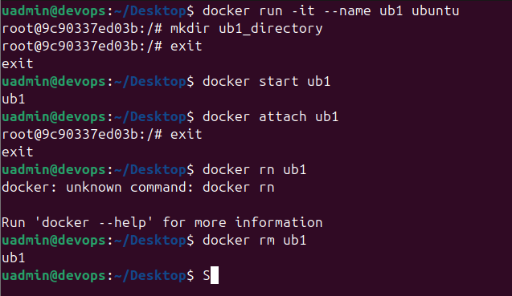

Q.2. Create a container using httpd image. Name the container as web1. map outside port 8000 to this container. Now try accessing the website using http://localhost:8000. Create an index.html file that will display your roll number and PRN. Copy this file inside the container to /usr/local/apache2/htdocs directory. Now got to http://localhost:8000 and check if the web site displays your web page. Stop and delete the container.

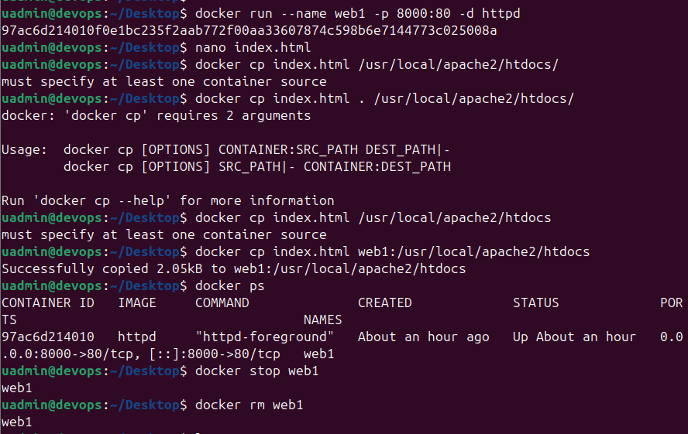
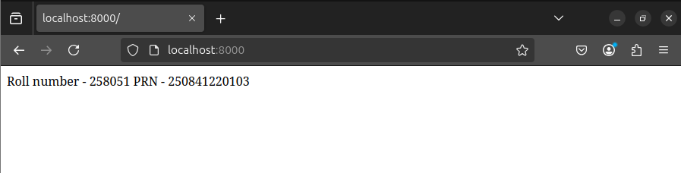

Q.3. Create a directory. Go to that directory.
mkdir web1
cd web1
Create your index.html file that will display your name and PRN number.
Create a dockerfile.
nano dockerfile

Add following to the file.

FROM httpd
COPY index.html /usr/local/apache2/htdocs/

Save the file. Use docker build command to build your application image.

docker build -t webapp1 . # Don’t forget dot at the end.

Now run the container using above image and verify.

docker run --name web3 -p 8000:80 -d webapp1

Now go to the browser and check by typing http://localhost:8000

